**WIRELESS VOICE AND IMAGE TRANSMISSION ROBOT FOR SURVEILLANCE SYSTEM**

**ABSTRACT**

The advent of new high-speed technology and the growing computer capacity provided realistic opportunity for new robot controls and realization of new methods of control theory. This technical improvement together with the need for high performance robots created faster, more accurate and more intelligent robots using new robots control devices, new drives and advanced control algorithms.

This project describes a new economical solution of robot control systems. The presented robot control system can be used for different sophisticated robot applications. The system can be viewed as two different modules- transmitter and receiver sections. The transmitter module consists of PC or TV, 433 MHz RF transmitter with HT12E 4 bit encoder and camera receiver to receive the data from camera which is mounted on robot. We have to choose the direction of the remote by pressing respective switches which are connected to HT12E.The data presented on HT12 is being transmitted to RF receiver through RF transmitter.

On the other hand, the receiver module receives the transmitted data and passes the data to the microcontroller. Thus, the microcontroller changes the direction of the robot according to the specified command. Since the microcontroller cannot drive the motors (used for robot) directly, L293D is used as a driver to provide the sufficient current required for the motors. The motors receive the input from the microcontroller and the required current from the power supply through L293D.

The robot will be equipped with camera and bomb detector. As it moves in the specified direction, if it encounters any person entering into the secured premises or if any bomb is found, the bomb detector immediately detects this and the microcontroller notices this and gives alert through buzzer. The output of the camera is given to the television where the entire view of the predefined location can be viewed all the time.

**BLOCK DIAGRAM**

**TRANSMITTER SIDE**

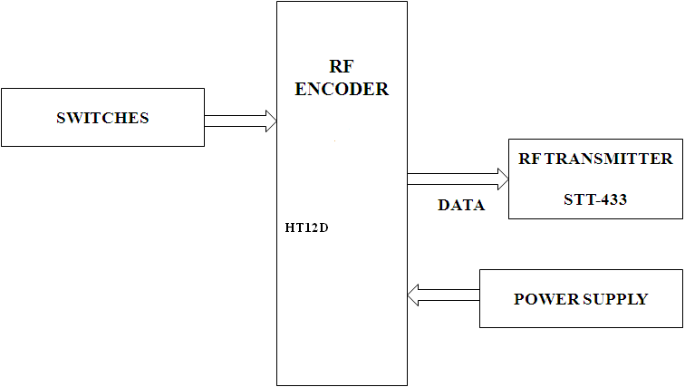

Camera receiver

PC or TV

**RECEIVER SECTION**

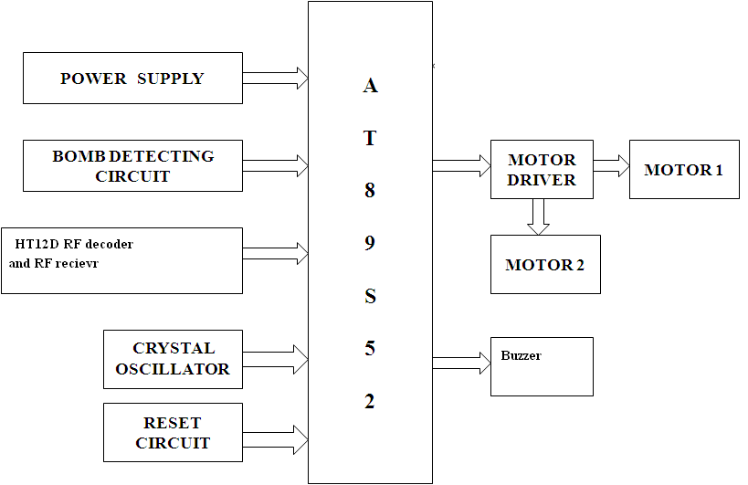

Camera image transmitter

**SOFTWARE AND HARDWARE TOOLS:**

**Software Tools:**

1. Keil compiler
2. Orcad.
3. Proload

**Hardware Tools:**

1. Microcontroller AT89S52.
2. PC or TV
3. Motors and driver circuit
4. RF module with HT12e and HT12d
5. Camera and receiver
6. Bomb detector